Treatment reports and device logs synchronisation

## The context

For the study purpose we need to collect information about how the treatment was performed (DTS Reports). Originally we thought that not all devices will have an internet connection. Moreover the synchronisation process between the device and server was not clear. To manage this we decided to have add a “Type of System” selector on the patient page that allows to select between:

* Automated - Treatment data is sent automatically based on the data collected from the device
* Manual - Patients manually fill out the following form

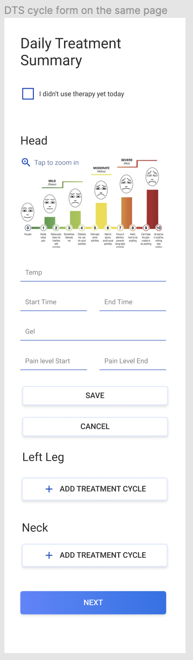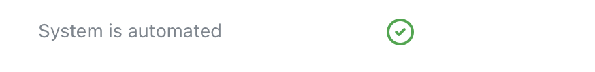

## Where we are

* Now the mobile application is an integral part of the system. We can rely on the fact that data is sent regularly
* The data we collect before and after the treatment was clarified:  
  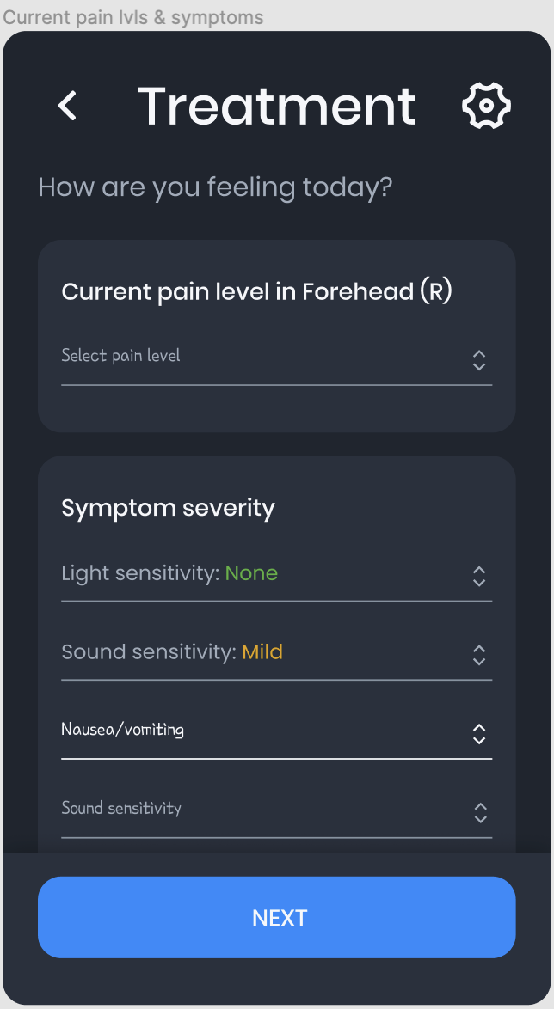
* The webform (DTS) seems to be outdated in comparison to the data that we collect from the patient and the info we can get from the device

## Solution

**General points**

1. As the application is a required part of the system, we can get rid of the related web form (DTS) and imply that we ~~have automated system type for all patients~~ do not divide patients into manual or automated type of system as they are going to follow the same workflow with the app (providing details before & after treatment via the app)
2. Treatment data is prepared on the application side and is sent to the server after each treatment. This information is used for the study.
3. In case the application doesn’t have internet connection it will send the treatment data later
4. Device logs are sent to the server separately and are not used for the study explicitly. However, the Thermaquil team should be able to view this data.

**Reports and visits**

At the moment the DTS Report is attached to a visit (= as we want to have information on the completed treatment displayed in the same place with the other assessment reports for a particular visit).

Currently we realize that the server may receive the treatment data with a significant delay (in case the app was offline), so we suggest implementing it the way that the server attaches the treatment data to a visit based on the treatment timestamp (= the report may appear within the visit not on the same day the treatment was completed).

**Report contents**

How we have much more clear information about what information we can show on the report. We suggest to show the following:

Section: **Before** Treatment

* Pain area
* Pain level
* Symptom severity (symptoms specified for the pain area in the daily diaries)

Section **Treatment**

List of cycles. Each item should have:

* Type: Hot / Cold
* Temperature
* Time

Section: **After** Treatment

* Pain area
* Pain level
* Symptom severity (symptoms specified for the pain area in the daily diaries)

Most likely you can collect more data from the device. Let us know if you want to send anything else to design the report for this data.  
  
**All treatments will appear as separate reports within a visit on the dashboard**. **In other words, since we send the data after each treatment, it will appear on the dashboard as separate treatment reports.**

API endpoints:

POST /assessment/treatment

GET /pain-areas

GET /symptoms

**Logs**

Logs are regularly gathered from the device and are sent to the server. Server doesn't analyse this data and saves it as is for future analysis by the Termaquil team.

API endpoints:  
POST /assessment/device-logs  
Accepts multiple records  
Log row format:

* Timestamp
* Event Type
* Event Data

GET /assessment/device-logs?limit=1&sortBy=timestamp&orderBy=1

This end-point should be used to get the latest sent record.